Use-Case Realization Report
Manage Role Approval

Issue <1.0>
Revision History
Date | Issue | Description | Author
30/JUL/2011 | 1.0 | First version | Alvin Chang

Table of Contents
1. Brief Description 4
2. Flow of Events 4
3. Interaction Diagrams 4
3.1 Approve Role Change 4
4. Participating Objects 4
5. Class Diagrams 5
5.1 Approval Role Change 5

Use-Case Realization Report
Manage Role Approval

Brief Description
This use case enables a director to approve a role change (assignment) by a department manager. (Refer to use case Manage Employee-Role).

Flow of Events
The standard flow of events for this use case and any exceptions are described in the following subsections. See section 3 for an overview of the participating Actors and Domain Objects.

2.1 Approve Role Change (Standard Flow)

- Director navigates to RoleApprovalPage via MainPage
- A list of available employees with their newly assigned (removed) roles will be displayed
- Department Manager approves or rejects role assignment.
- System will update role approval into database.
- This marks the end of this use case.

Interaction Diagrams

Approve Role Change
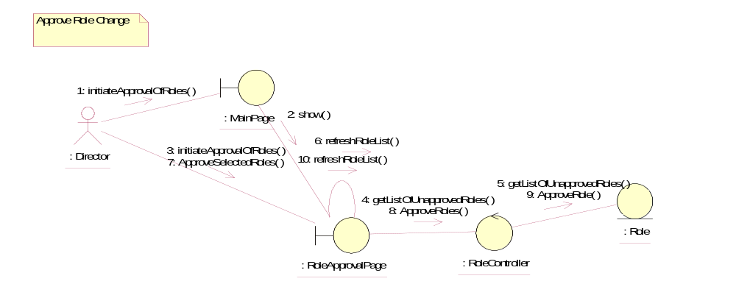

Participating Objects
: Director
This actor represents a director in Golden Gravure.

: Role
This object contains information about the roles.

: RoleApprovalPage
This page represents the UI where the Director will approve / reject the roles assigned to or removed from an employee.

: RoleController
This object controls the operations of the Role object.

: MainPage
This page represents the UI where the user of the system will first enter, and act as a launchpad for the other various pages within the system.

Class Diagrams

Approval Role Change
